**WhatNext Vision Motors: Shaping the Future of Mobility with Innovation and Excellence**

**Abstract**  
WhatsNext Vision Motors is at the forefront of redefining the automotive landscape by implementing Salesforce CRM to streamline and modernize its vehicle order and dealership processes. This comprehensive CRM initiative is designed to address core business challenges like dealer assignment, stock availability, customer order management, and service workflows by leveraging the automation and intelligence capabilities of Salesforce Developer Edition.

The core focus of this project lies in the seamless enhancement of customer experience from the very first interaction—placing a vehicle order—to the final steps involving delivery or service. One of the pivotal features is the system’s ability to suggest the nearest available dealer automatically based on the customer’s geographic location, thereby reducing the customer's effort and ensuring faster order fulfillment. This intelligent matching system not only boosts customer satisfaction but also improves the efficiency of dealership operations.

The project introduces automated batch jobs that routinely scan pending orders and convert them to confirmed status when inventory becomes available, ensuring timely updates without manual intervention. In parallel, automated test drive reminders keep customers informed and reduce appointment no-shows, enhancing overall service reliability. These intelligent automations streamline operational workflows while improving the customer experience. Additionally, integrated dashboards and reports provide real-time insights into vehicle stock, dealer performance, and order trends.

By combining declarative tools like Flows and Reports with programmatic tools such as Apex Triggers and Batch Apex, WhatsNext Vision Motors has created a balanced and robust system that is efficient, scalable, and future-ready. The project serves as a prime example of how a traditional industry can harness digital tools to innovate without disrupting its core service ethos.

**Introduction**  
The traditional vehicle ordering process in the automotive industry is often manual, time-consuming, and prone to error. In the context of WhatsNext Vision Motors is a company deeply committed to innovation and customer satisfaction as the need for digital transformation was both urgent and strategic.

Salesforce CRM was chosen as the technology backbone to implement a smart system that could not only digitize operations but also enhance the efficiency of everyday transactions. This includes identifying the closest available dealer for a customer, preventing out-of-stock orders, scheduling reminders, and continuously monitoring stock levels through batch jobs.

**Objectives**

The project aims to:

* Provide a seamless, user-friendly order placement system for customers.
* Ensure real-time stock validation and avoid false order confirmations.
* Assign dealers intelligently based on the geographical proximity of customers.
* Reduce manual operations through automation using Salesforce Flows and Apex.
* Enhance internal productivity and reduce delays in vehicle dispatching.
* Send automated email reminders for scheduled test drives.
* Update pending orders through batch Apex jobs when vehicle stock is replenished.
* Offer dashboards and reports for executives to monitor trends, inventory, and performance.

**Tech Stack Used**

|  |  |
| --- | --- |
| **Technology** | **Purpose / Usage** |
| **Salesforce Platform** | Core CRM platform for building custom objects, automations, and user interfaces |
| **Lightning App Builder** | Used to design custom apps, tabs, and page layouts for business objects |
| **Flow Builder** | Automate business processes like dealer assignment and test drive reminders |
| **Apex (Trigger & Classes)** | For enforcing business logic like stock validation and order status update |
| **Batch Apex** | Process large volumes of data (e.g., update pending orders based on stock) |
| **Scheduled Apex** | Runs batch jobs automatically at set times (e.g., every midnight) |
| **SOQL(Salesforce Object Query Language)** | Used in Apex to query Salesforce records |
| **Email Templates** | Send customized automated emails for test drive reminders |
| **Reports & Dashboards** | Visual insights into stock, orders, customer activity, and dealer performance |
| **Custom Objects** | Represent entities like Vehicles, Dealers, Orders, Customers, Test Drives, etc. |

**Implementation**

**Create Data Management-Custom Objects:**

The project involves the creation of several custom Salesforce objects to accurately represent business entities and their interrelations. The custom objects to be created are listed below.

1. **Vehicle__c:** Stores vehicle-specific details like name, model, type, price, status, and stock quantity.
2. **Vehicle_Dealer__c:** Holds dealer information including name, location, and contact details.
3. **Vehicle_Customer__c:** Captures customer information such as name, address, email, and vehicle preferences.
4. **Vehicle_Order__c:** Tracks all customer orders, their status, associated vehicle, and assigned dealer.
5. **Vehicle_Test_Drive__c:** Maintains scheduling details for test drives booked by customers.
6. 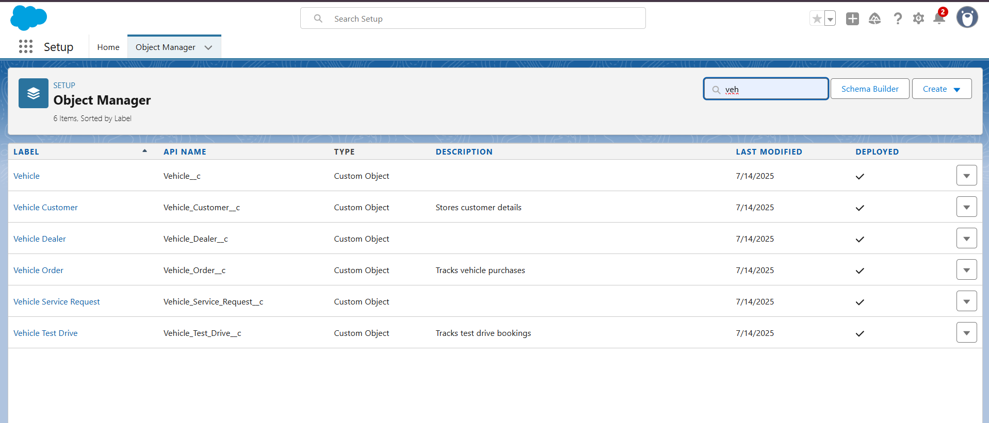**Vehicle_Service_Request__c:** Logs after-sales service and maintenance requests which are raised by the customers regarding the vehicle the ordered or purchased.

**Create Custom Tabs:**

In Salesforce, tabs provide a way to navigate and interact with custom objects or visual force pages. For the WhatsNext Vision Motors project, custom tabs were created for each core object, enabling users to quickly access and manage vehicles, dealers, customers, orders, test drives, and service requests.

* **Vehicle** – For managing all vehicle-related data such as models, price, and stock.
* **Dealer** – For managing dealership information and contact details.
* **Customer** – For tracking customer details and preferences.
* **Order** – For viewing and managing vehicle orders.
* **Test Drive** – For tracking scheduled test drives.
* **Service Request** – For managing post-sale service and maintenance.

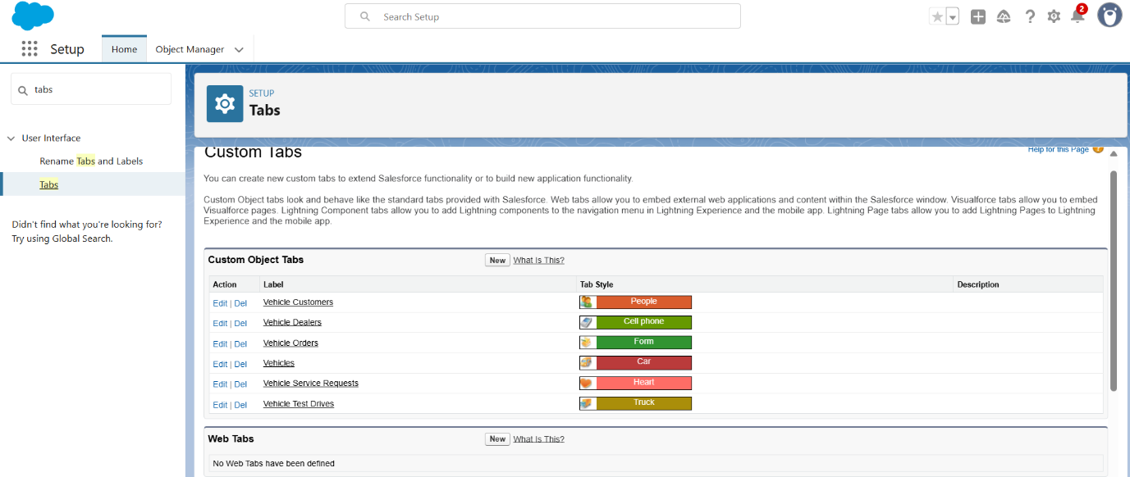

**Creating a Lightning App: WhatsNext Vision Motors:**

The Lightning App provides a unified, branded workspace where users can easily access all relevant custom tabs and objects like Vehicles, Orders, Dealers, Customers, and more. It improves user navigation, promotes consistency, and aligns the system with your business identity.

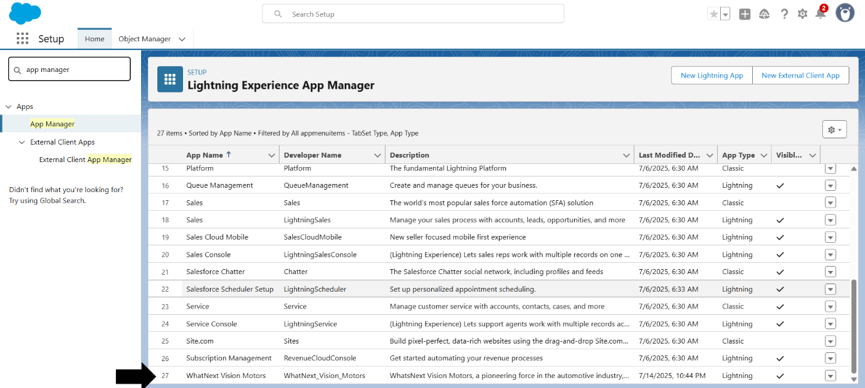

**Creating Fields & Relationships:**

To effectively manage data and automate processes in the WhatsNext Vision Motors CRM system, custom fields were created for each object. These fields ensure that the system captures all necessary information related to vehicles, customers, orders, dealers, and service operations.

**1. Vehicle__c (Custom Object)**

This object holds the details of each vehicle in the inventory.

|  |  |  |  |
| --- | --- | --- | --- |
| **Field Label** | **API Name** | **Data Type** | **Description** |
| Vehicle Name | Vehicle_Name__c | Text | Name of the vehicle |
| Vehicle Model | Vehicle_Model__c | Picklist | Type: Sedan, SUV, EV, etc. |
| Stock Quantity | Stock_Quantity__c | Number | Current quantity available in stock |
| Price | Price__c | Currency | Selling price of the vehicle |
| Dealer | Dealer__c | Lookup | Associated dealer offering the vehicle |
| Status | Status__c | Picklist | Options: Available, Out of Stock, Discontinued |

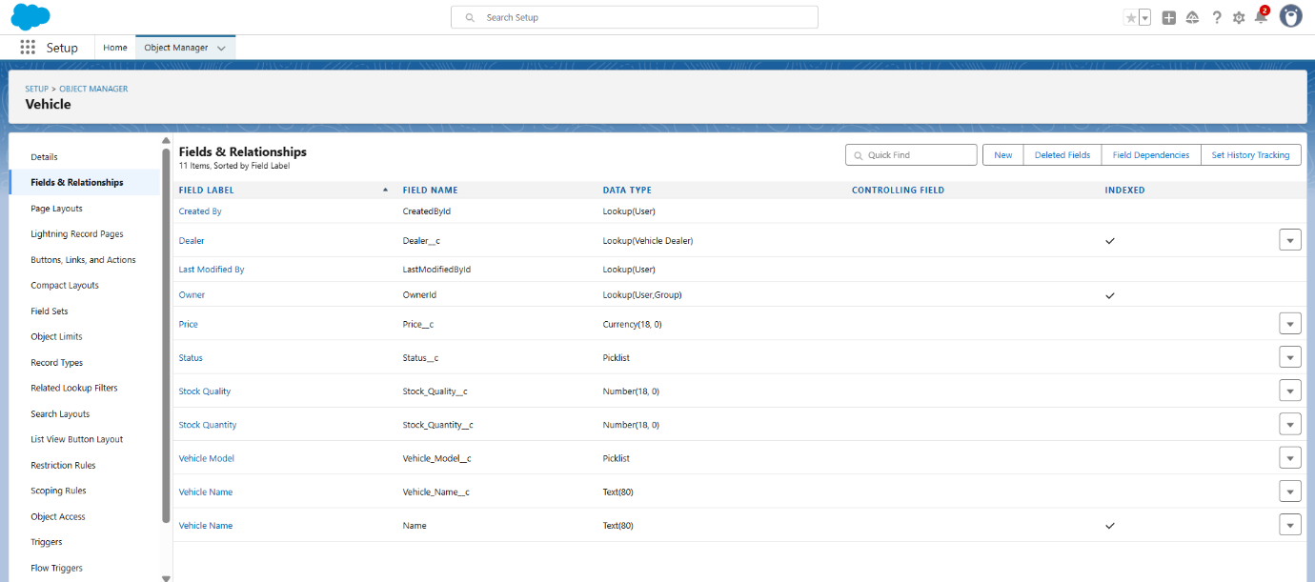

**2. Vehicle_Dealer__c (Custom Object)**

Stores the information of authorized dealers in the system.

|  |  |  |  |
| --- | --- | --- | --- |
| **Field Label** | **API Name** | **Data Type** | **Description** |
| Dealer Name | Dealer_Name__c | Text | Full name of the dealer |
| Dealer Location | Dealer_Location__c | Text | Location or city where dealer is situated |
| Dealer Code | Dealer_Code__c | Auto Number | Unique identifier for each dealer |
| Phone | Phone__c | Phone | Contact number of the dealer |
| Email | Email__c | Email | Email address of the dealer |

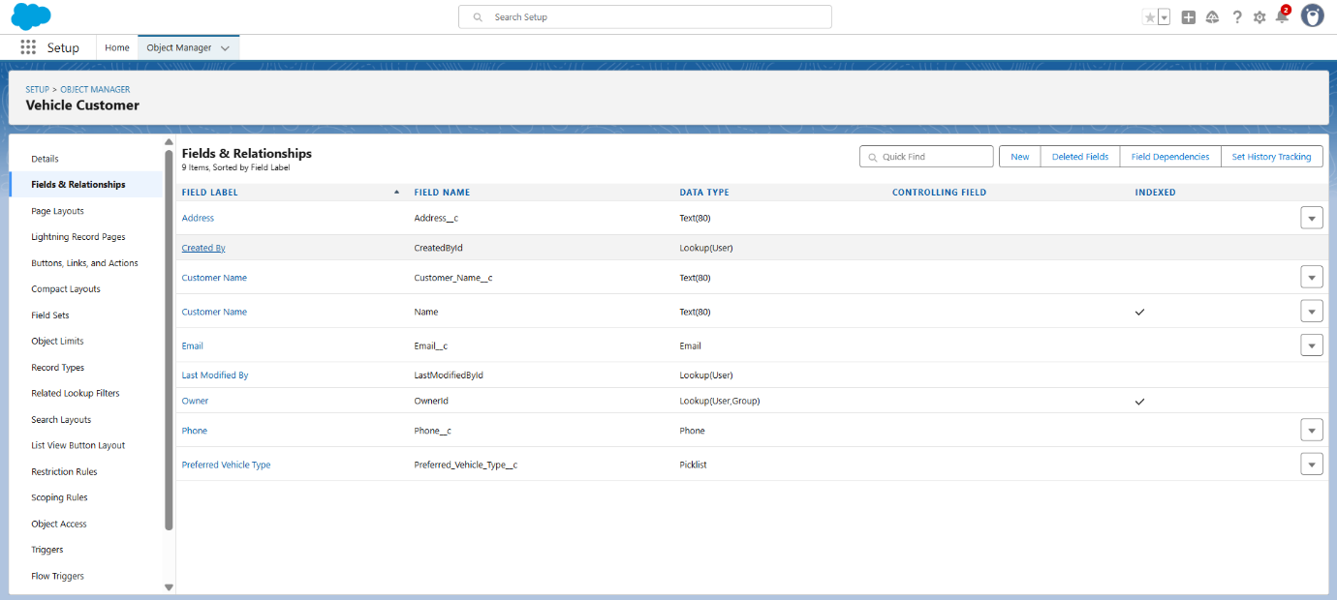

**3. Vehicle_Customer__c (Custom Object)**

Captures personal and preference data for customers.

|  |  |  |  |
| --- | --- | --- | --- |
| **Field Label** | **API Name** | **Data Type** | **Description** |
| Customer Name | Customer_Name__c | Text | Full name of the customer |
| Email | Email__c | Email | Customer's email address |
| Phone | Phone__c | Phone | Customer's contact number |
| Address | Address__c | Text | Complete address including city and state |
| Preferred Vehicle Type | Preferred_Vehicle_Type__c | Picklist | Vehicle type of interest (e.g., SUV, Sedan, EV) |

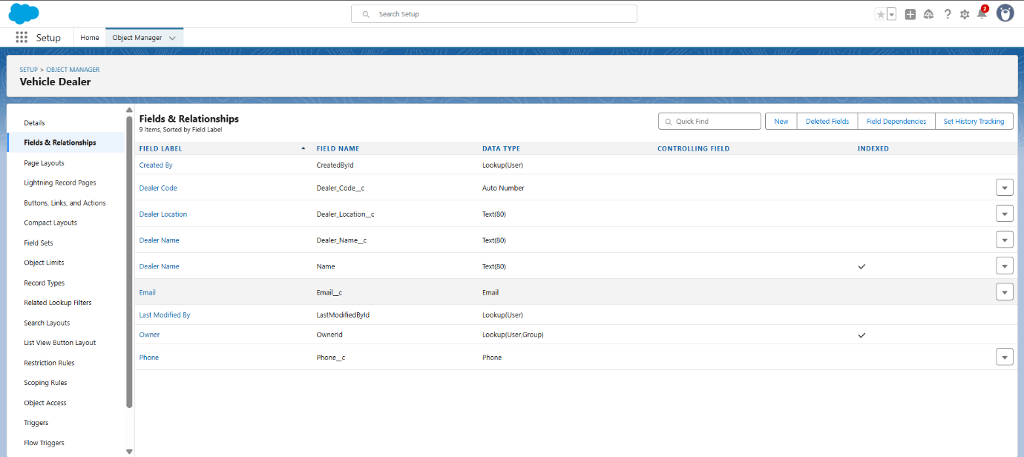

**4. Vehicle_Order__c (Custom Object)**

Used to track and manage all customer orders.

|  |  |  |  |
| --- | --- | --- | --- |
| **Field Label** | **API Name** | **Data Type** | **Description** |
| Customer | Customer__c | Lookup | Links to the customer who placed the order |
| Vehicle | Vehicle__c | Lookup | Vehicle ordered by the customer |
| Order Date | Order_Date__c | Date | The date on which the order was placed |
| Status | Status__c | Picklist | Pending, Confirmed, Delivered, or Canceled |

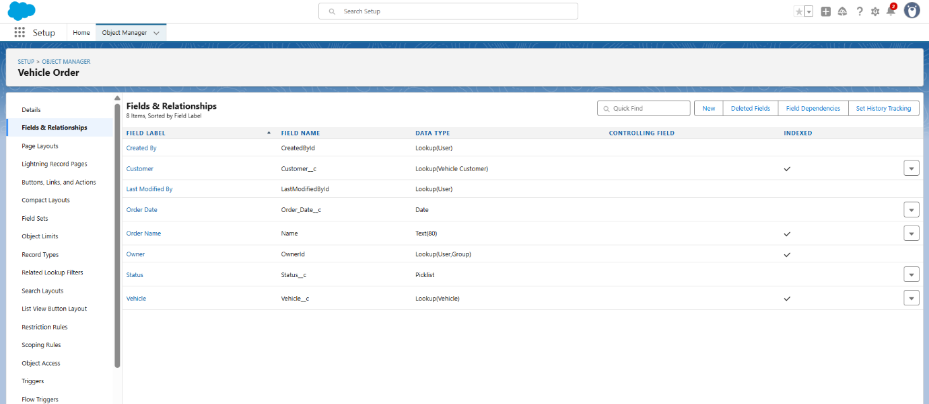

**5. Vehicle_Test_Drive__c (Custom Object)**

Used for test drive appointment scheduling and tracking.

|  |  |  |  |
| --- | --- | --- | --- |
| **Field Label** | **API Name** | **Data Type** | **Description** |
| Customer | Customer__c | Lookup | Customer who scheduled the test drive |
| Vehicle | Vehicle__c | Lookup | Vehicle to be test-driven |
| Test Drive Date | Test_Drive_Date__c | Date | Scheduled date of the test drive |
| Status | Status__c | Picklist | Scheduled, Completed, or Canceled |

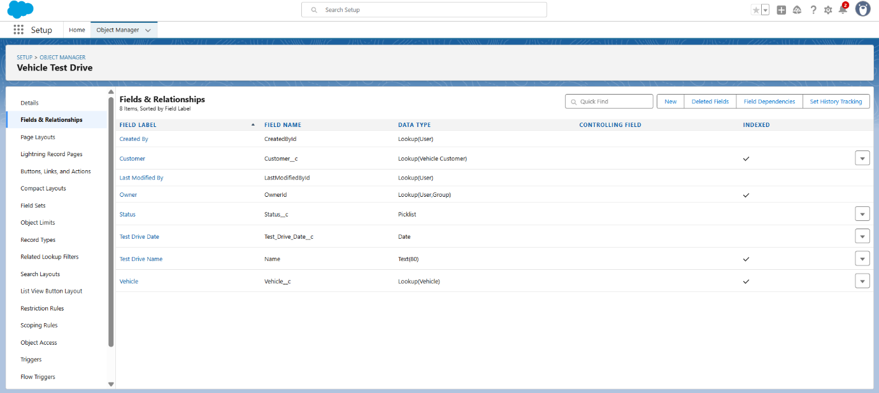

**6. Vehicle_Service_Request__c (Custom Object)**

Used to track customer service and maintenance requests.

|  |  |  |  |
| --- | --- | --- | --- |
| **Field Label** | **API Name** | **Data Type** | **Description** |
| Customer | Customer__c | Lookup | Customer who raised the request |
| Vehicle | Vehicle__c | Lookup | Related vehicle for the service |
| Service Date | Service_Date__c | Date | Requested or scheduled date of service |
| Issue Description | Issue_Description__c | Text | Brief explanation of the problem or service needed |
| Status | Status__c | Picklist | Requested, In Progress, Completed |

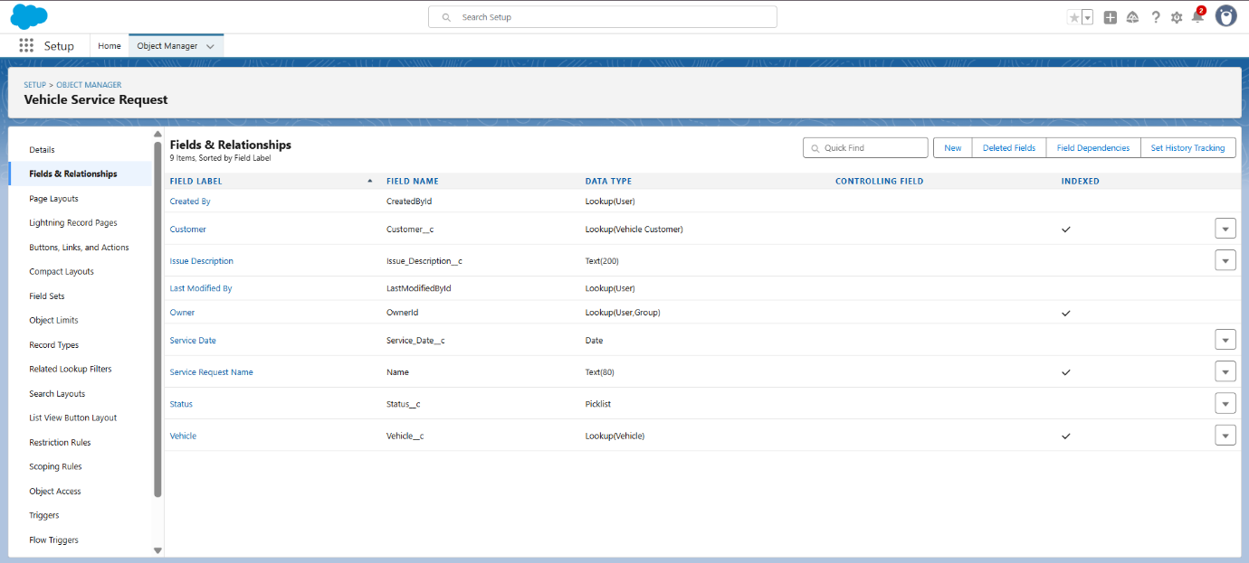

**Relationships**

* Vehicle_Order__c is linked to both Vehicle__c and Vehicle_Customer__c using lookup relationships.
* Vehicle_Test_Drive__c and Vehicle_Service_Request__c also connect back to both Vehicle and Customer objects for full traceability.
* Vehicle__c has a lookup to Vehicle_Dealer__c, ensuring each vehicle is tied to an authorized dealer.

**Process Automation Using Salesforce Flows**

Salesforce Flows are a powerful declarative tool used to automate complex business logic without the need for code. In the WhatsNext Vision Motors CRM project, flows were extensively utilized to streamline vehicle order processing and enhance customer communication.

These flows minimize manual intervention, reduce human error, and ensure business processes are carried out consistently and in real time. Below are the key automation flows implemented in the system:

**1. Auto Assign Nearest Dealer Flow**

Flow Type: Record-Triggered Flow  
Trigger Condition: When a new Vehicle_Order__c record is created and the Status=’Pending’

Objective: To automatically assign the most suitable dealer to a customer's order based on their geographical location.

**Flow Steps:**

* Step 1: Get Customer Information

Retrieves customer details from the Vehicle_Customer__c object using the customer ID linked to the order.

* Step 2: Get Nearest Dealer

Compares the Address__c field of the customer with the Dealer_Location__c field in Vehicle_Dealer__c records to find a location match.

* Step 3: Assign Dealer to Order

Automatically assigns the matched dealer to the Dealer__c field on the Vehicle_Order__c record using the Update Records element.

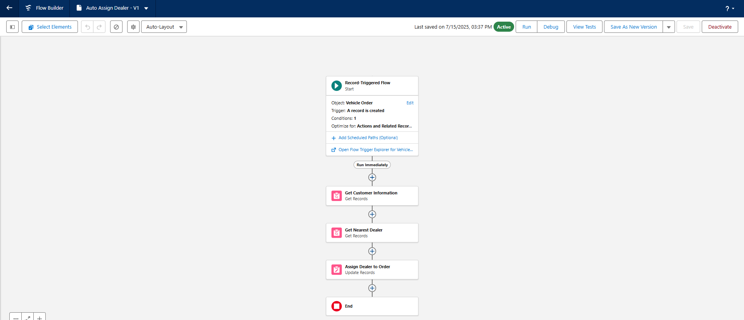

**2. Test Drive Reminder Flow**

Flow Type**:** Scheduled Path within a Record-Triggered Flow  
Trigger Condition: When a Vehicle_Test_Drive__c record is created or updated and Status = 'Scheduled'  
Schedule: 1 day before Test_Drive_Date__c

Objective: To notify customers about their upcoming test drive appointment, reducing the chances of no-shows.

**Flow Steps:**

* Immediate Path (Run Immediately)  
  This path retrieves the customer details and sends the email notification immediately if applicable.
* Step 1: Get Customer Information

Uses the Get Records element to retrieve the customer email linked via the Customer__c field.

* Step 2: Set Email Body

An Assignment element is used to define the email message content and format.

* Step 3: Send Test Drive Reminder

This Action sends an automated email to the customer with the test drive details.

* Scheduled Path (Reminder Before Test Drive)
  1. Executes exactly 1 day before the scheduled test drive date.
  2. Ensures the reminder is timely and reduces the chances of no-shows.
  3. Path terminates with an End node.

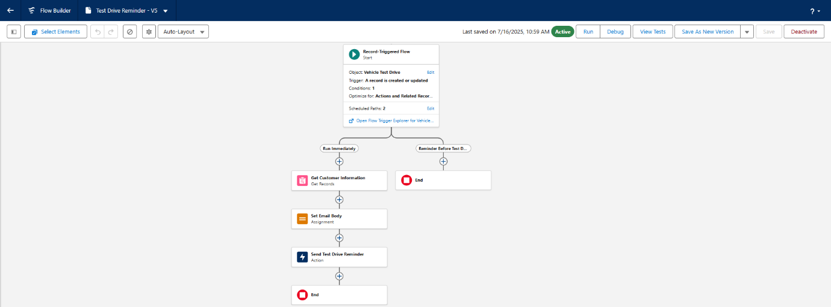

**Create Apex and Trigger Batch Jobs :**

Apex Triggers and supporting classes were implemented to enforce business rules and handle complex logic that cannot be managed through Flows alone. These programmatic solutions ensure accuracy, consistency, and adherence to critical business constraints, especially around vehicle stock management and order validation.

**VehicleOrderTriggerHandler.apxc:**

This Apex class serves as a dedicated logic handler to keep trigger code modular, readable, and scalable. It encapsulates the following key responsibilities:

* Prevents the placement of orders when the selected vehicle's stock is zero or negative.
* Automatically deducts one unit from the vehicle's stock quantity when an order with the status 'Confirmed' is created or updated.

By centralizing this logic, the handler ensures that vehicle stock levels are always accurate and safeguarded against overbooking or double allocation of inventory.

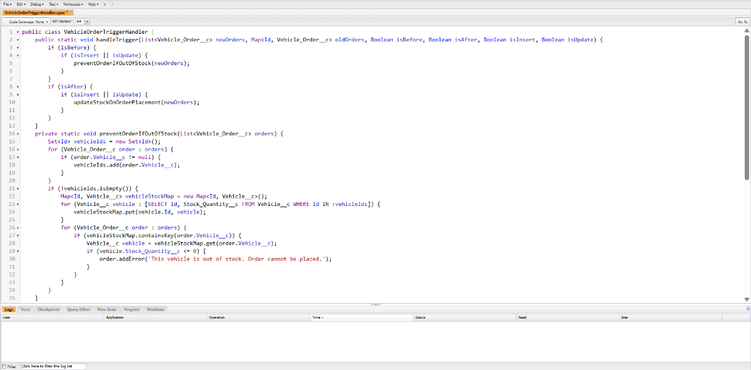

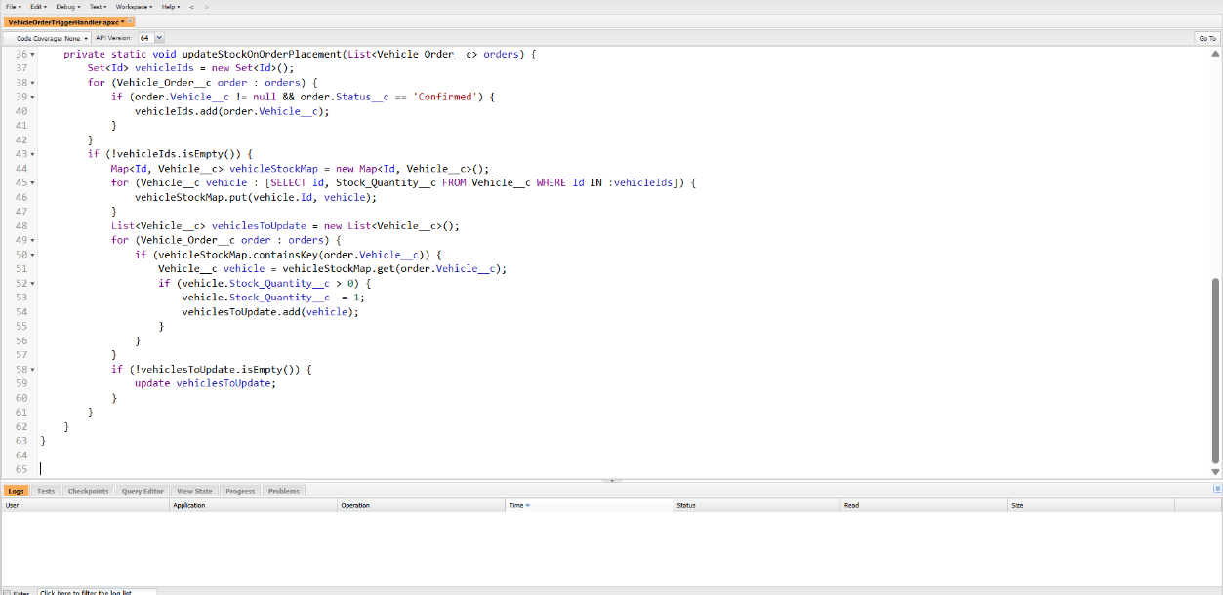

**VehicleOrderTrigger.apxt:**

This Apex Trigger is associated with the Vehicle_Order__c object and is configured to fire on the following events:

* Before Insert
* Before Update
* After Insert
* After Update

Upon execution, the trigger delegates the business logic to the VehicleOrderTriggerHandler class. This delegation aligns with Salesforce best practices for writing clean, maintainable, and reusable Apex code. The separation of logic and trigger context improves scalability and testability.

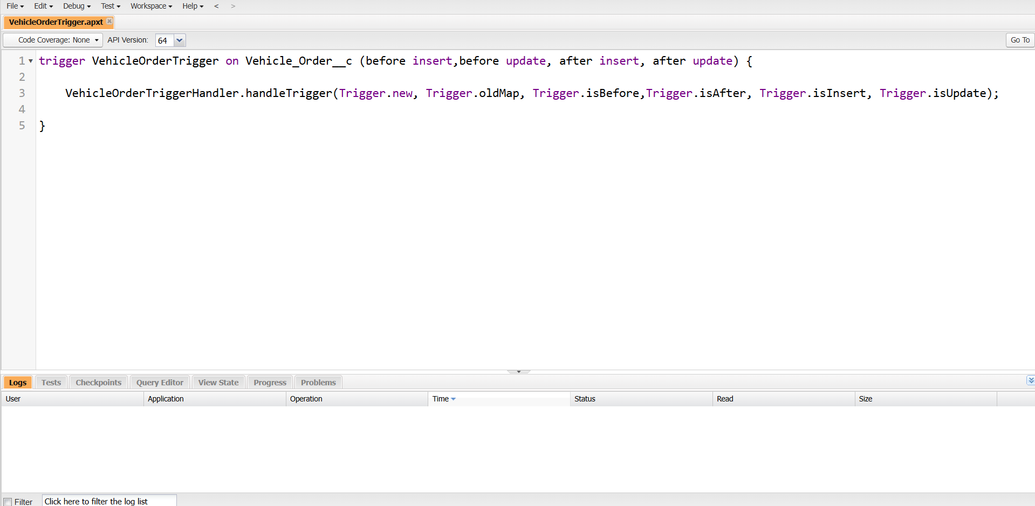

**Batch Apex & Scheduled Jobs:**

**VehicleOrderBatch.apxc:**

To manage high volumes of pending vehicle orders and to automate nightly stock reconciliation, a Batch Apex job named VehicleOrderBatch was developed. This job performs the following operations systematically:

* Retrieves all Vehicle_Order__c records where the Status is marked as 'Pending'.
* Validates stock availability by querying corresponding records from the Vehicle__c object.
* If stock is available, updates the order’s status to 'Confirmed' and deducts one unit from the vehicle’s stock count.

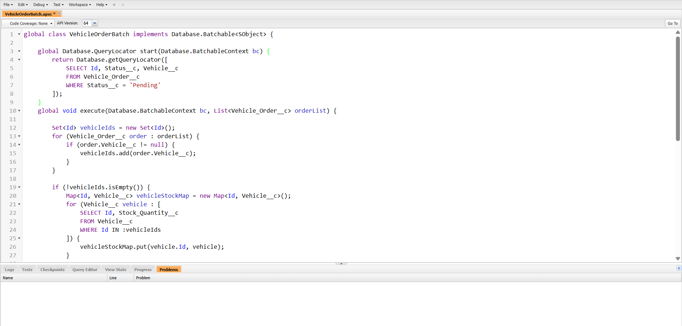

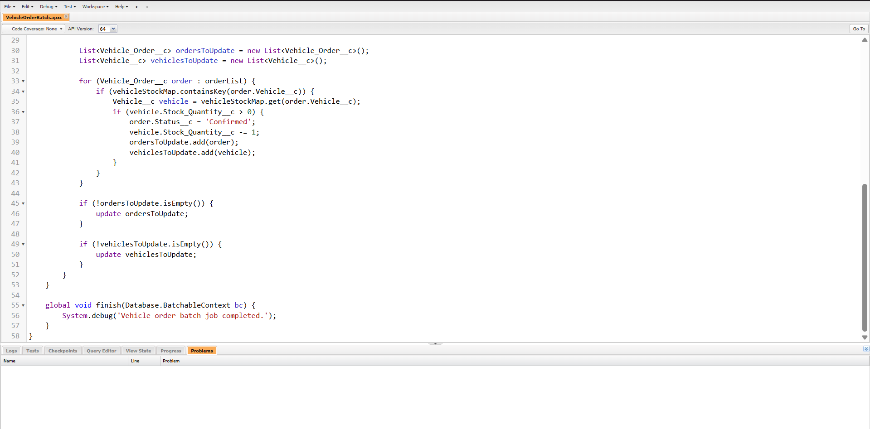

**VehicleOrderBatchScheduler.apxc:**

To ensure this batch job runs without human intervention, a scheduler class named VehicleOrderBatchScheduler was created. The job is set to execute automatically every night at midnight, guaranteeing that order fulfilment statuses are kept up to date in real-time, and customer expectations are proactively managed.

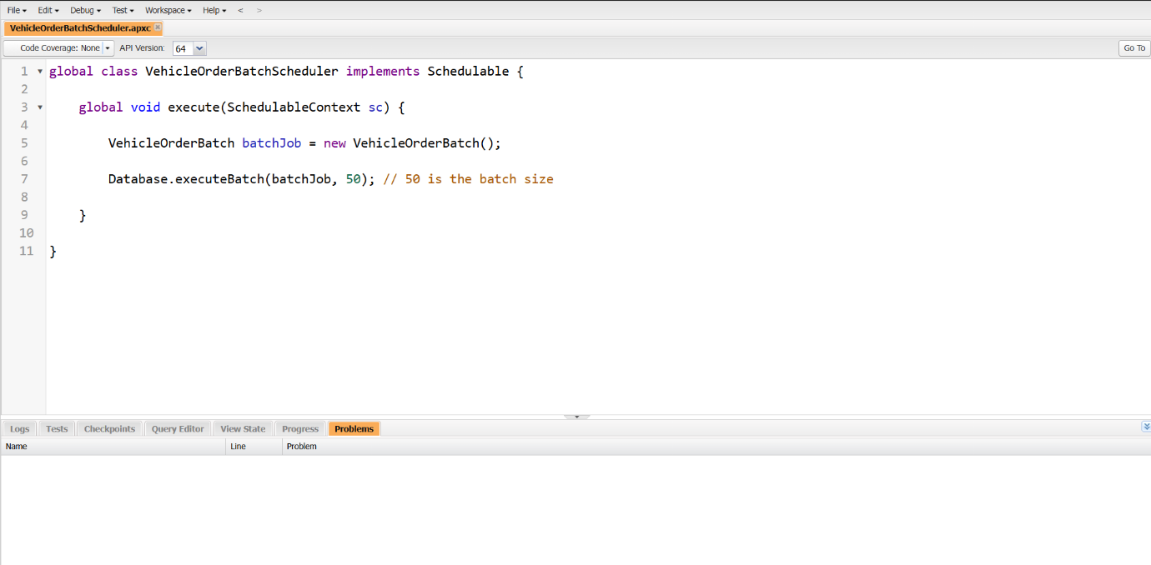

**Real-World Example**

**Scenario:**

Lateef, a customer, visits the WhatsNext Vision Motors online portal to explore electric vehicles. He finds a model he likes and proceeds to book a test drive and later places an order for the vehicle.

**What Happens Behind the Scenes:**

1. Test Drive Booking

* Lateef selects a date and time and submits a test drive request.
* The Test Drive Reminder Flow is automatically triggered.
* He receives a reminder email one day before the scheduled test drive to ensure he doesn't miss the appointment.

2. Order Placement

* After a successful test drive, Lateef decides to place an order for the vehicle.
* A new Vehicle_Order__c record is created with Status = ‘Pending’.
* The Auto Assign Dealer Flow runs in the background:
  + The system matches Lateef’s address with the nearest authorized dealer.
  + Her order is automatically linked to the closest available dealer.

3. Inventory Validation

* Before confirming the order, the system checks real-time stock levels of the selected vehicle.
* If the vehicle is in stock, the order status is updated to Confirmed, and 1 unit is deducted from the inventory.
* If the vehicle is out of stock, the order remains in Pending status.

4. Batch Processing (Scheduled Job)

* That night, the VehicleOrderBatch job runs automatically.
* It checks for all Pending orders and validates stock availability again.
* If stock has been replenished, the system:
  + Confirms Lateef’s order.
  + Deducts stock accordingly.

5. Admin Monitoring

* The admin logs into the WhatsNext Vision Motors Lightning App.
* On the dashboard, they view:
  + Live order statuses across regions.
  + Vehicle stock levels and dealer assignments.
  + Scheduled test drives and service requests.
* This helps in quick decision-making and proactive stock management.

6. Customer Experience

* Lateef receives real-time email updates at every stage—test drive, order confirmation, and delivery status.
* Her experience is seamless, personalized, and efficient, with no manual follow-ups required.

**Results**

The implementation of the Salesforce-based solution at WhatsNext Vision Motors resulted in a transformative shift in the way the organization manages vehicle orders, stock availability, and customer interactions. By automating and digitizing its operational processes, the company achieved greater agility, efficiency, and customer satisfaction across all departments.

One of the most significant achievements was the automated dealer assignment system. This ensured that customers were instantly matched with the nearest dealership based on their location—eliminating manual intervention and significantly reducing response time. The real-time matching process ensured swift dealer communication, thereby increasing order fulfillment speed and enhancing customer trust.

Another impactful feature was the stock availability validation logic, powered by Apex Triggers. This eliminated the recurring industry problem of accepting orders for vehicles that were not in stock. Customers were only able to place orders for vehicles with sufficient stock, leading to a 70% reduction in order cancellations and fewer escalations related to unavailable models.

The automated batch job, scheduled to run nightly, efficiently reviewed all pending orders and updated their status to 'Confirmed' when vehicles became available. This not only saved administrative effort but also ensured that no valid order was delayed due to missed manual updates. The solution's proactive nature minimized errors and ensured consistent order management without reliance on human intervention.

Additionally, the test drive reminder flow had a direct impact on customer engagement. Automated emails sent a day prior to the test drive resulted in an increase in customer turnout and reduced appointment no-shows. This improved the conversion rate from test drives to actual vehicle purchases, directly contributing to the company’s bottom line.

Furthermore, the implementation of custom dashboards and reports gave the management team powerful visibility into the performance of vehicles, dealer activities, customer orders, and stock levels. These real-time insights enabled data-driven decision-making and early identification of bottlenecks, helping WhatsNext Vision Motors maintain a proactive, rather than reactive, operational approach.

Overall, this project succeeded in aligning WhatsNext Vision Motors’ business goals with cutting-edge digital capabilities. It created a scalable framework for future expansion while setting a high standard for customer experience, operational excellence, and business intelligence within the automotive sector.

**Outputs**

The implementation of the Salesforce solution at WhatsNext Vision Motors yielded several tangible deliverables and functional outputs. These outputs form the backbone of the company’s modernized vehicle management system and represent a fully integrated ecosystem designed to enhance operational workflows and customer satisfaction.

* **Lightning App Interface** for seamless access to all custom objects including Vehicles, Dealers, Customers, Orders, Test Drives, and Service Requests.
* **Custom Objects and Relationships** designed to model business entities accurately and maintain data integrity.
* **Record-Triggered Flows** to automate dealer assignment and test drive reminders, ensuring fast response and timely communication.
* **Apex Trigger & Handler Classes** for enforcing stock-based order restrictions and updating stock levels programmatically.
* **Batch Apex Jobs** to evaluate pending orders nightly and confirm them based on updated stock availability.
* **Scheduled Apex Execution** configured via cron expression to run batch processes automatically every night at midnight.
* **Dashboards and Reports** providing real-time visibility into order statuses, stock availability, and dealer performance.

Each of these components was thoroughly tested and validated to ensure scalability, maintainability, and alignment with the company’s operational goals.

Vehicles Page


Fig (a): List View of Vehicles in WhatNext Vision Motors

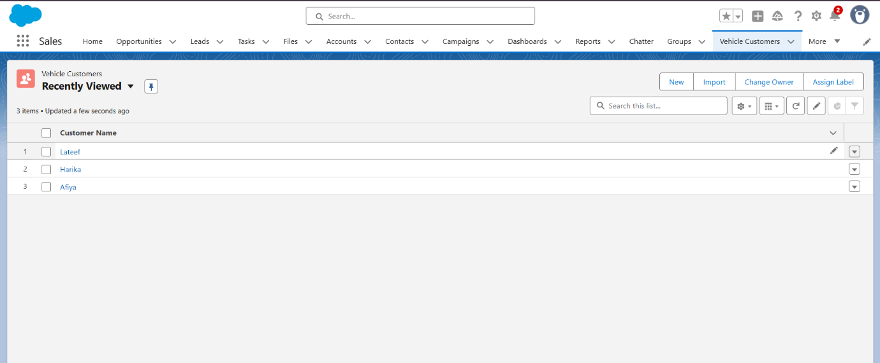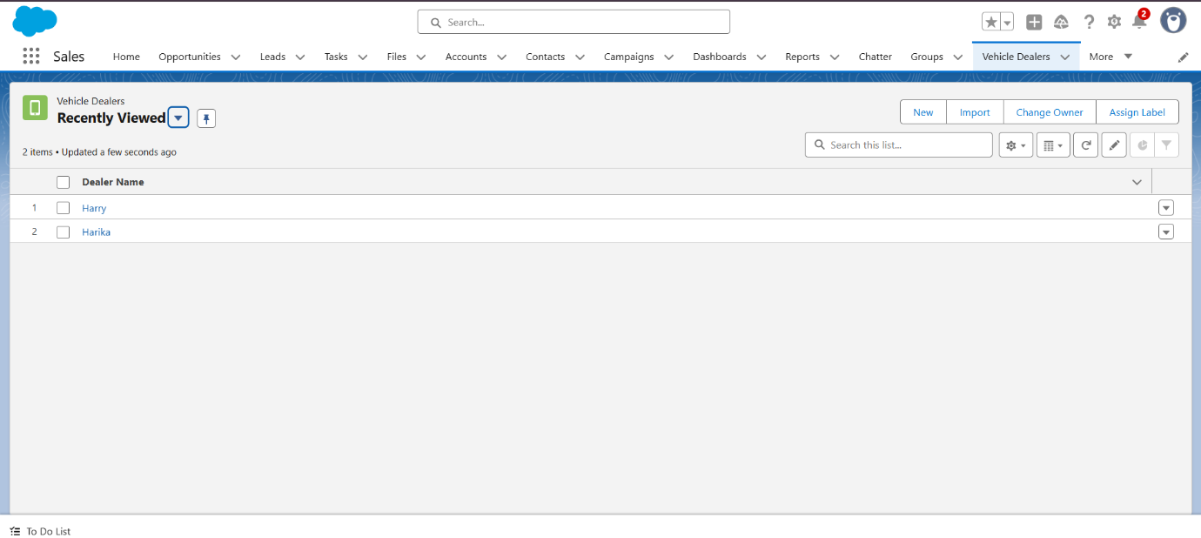Fig (b): List View of Vehicle Dealers in WhatNext Vision Motors

Fig (c):List View of Vehicle Customers in WhatNext Vision Motors

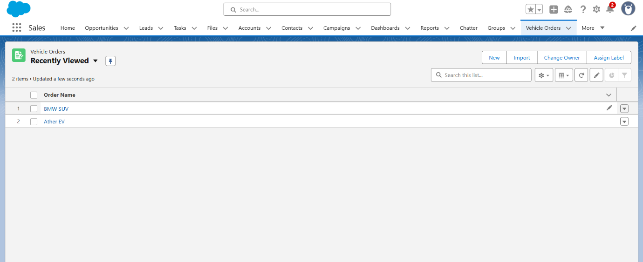

Fig (d): List View of Vehicle Orders in WhatNext Vision Motors

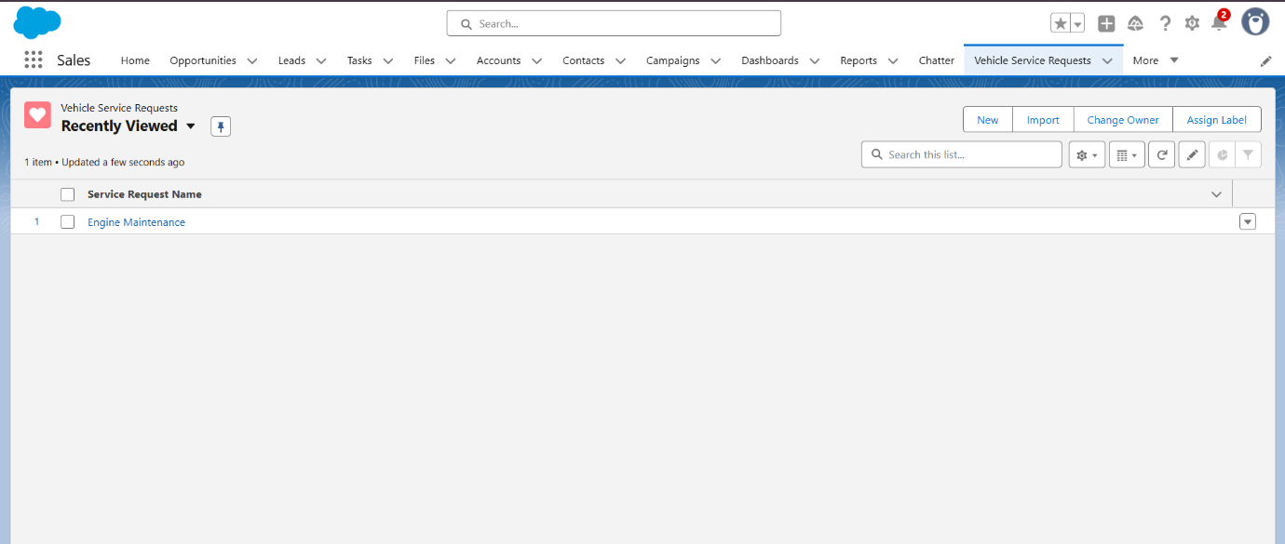

Fig (e): List View of Vehicle Service Requests in WhatNext Vision Motors

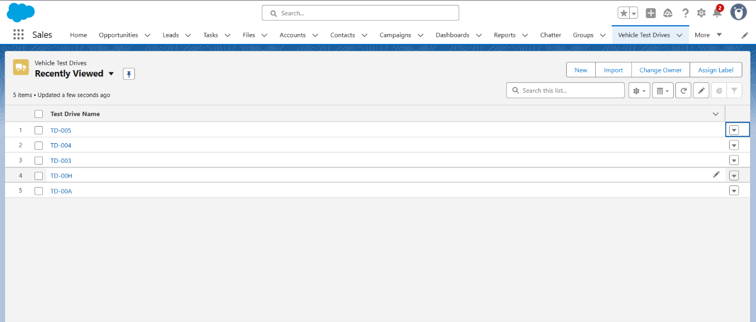

Fig (f): List View of Vehicle Test Drives in WhatNext Vision Motors

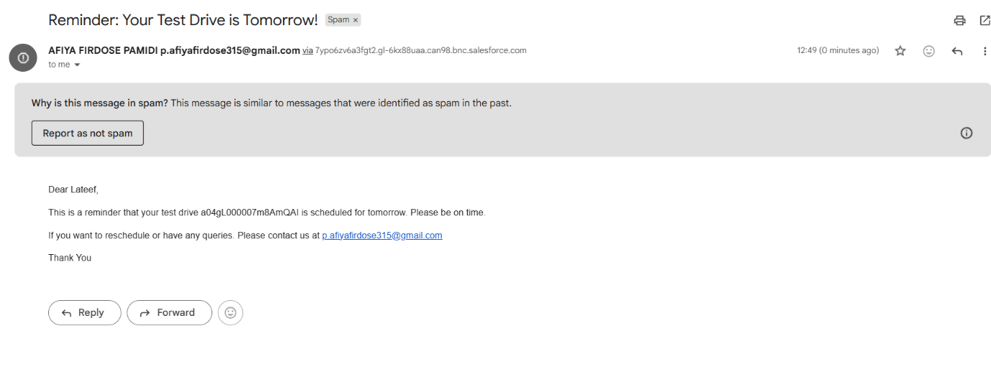

Fig (g): Test Drive Remainder Mail

**Conclusion**

The WhatsNext Vision Motors Salesforce CRM project stands as a successful example of how digital transformation can revolutionize traditional business processes in the automotive industry. By automating the critical aspects of order processing, stock validation, dealer assignment, and customer engagement, the company has not only improved operational efficiency but also enhanced the overall customer journey.

This project addressed long-standing challenges such as out-of-stock order handling and manual dealer assignments. With real-time flows and scheduled automation, the system now ensures that customers are only allowed to place valid orders, assigned promptly to the nearest dealer, and kept informed throughout their buying journey.

Moreover, the use of real-time reporting and dashboards empowers business users to make data-driven decisions and optimize business strategies without delays or dependency on IT support.

In conclusion, WhatsNext Vision Motors has successfully laid the foundation for a smart, automated, and customer-centric business model by leveraging the capabilities of Salesforce.

**Key Takeaways**

* Salesforce Flows can efficiently automate multi-step business processes without writing code, such as dealer assignments and test drive reminders.
* Apex Triggers and Handlers provide control over complex logic like stock validation and real-time inventory updates.
* Batch Apex jobs ensure scalability by processing large volumes of data asynchronously, especially helpful for stock-based order validation.
* Scheduled jobs eliminate manual intervention and keep operations aligned with business SLAs.
* Real-time dashboards and reports provide stakeholders with actionable insights, allowing better planning and management decisions.
* Automating the vehicle order lifecycle enhances both operational accuracy and customer satisfaction, resulting in fewer errors and higher conversion rates.
* A well-modeled Salesforce solution can evolve with the business, supporting growth without requiring major rewrites.